Online Footwear Shopping

Submitted in partial fulfillment of the requirements

of the Mini-Project 1 for Second Year of

Bachelors of Engineering

by

Mohammed Jawwad – 01   
 Rohit Nagawelly - 31   
 Shailesh Mishra - 28

Guide:

Prof. Reshma Lohar



Department of Computer Engineering

Rizvi College of Engineering



University of Mumbai

2021-2022

**CERTIFICATE**

This is to certify that the mini-project entitled **“Online Footwear Shopping”** is a bonafide work of **Mohammed Jawwad, Rohit Nagawelly, Shailesh Mishra Roll No.: 01, 31, 28** submitted to the University of Mumbai in partial fulfillment of the requirement for the Mini-Project 1 for Second Year of the Bachelor of Engineeringin **“Computer Engineering”**.

Name and sign

**Guide**

_______________ ______________

Prof. Shiburaj Pappu Dr. Varsha Shah

**Head of Department** **Principal**

**Declaration**

We declare that this written submission represents my ideas in my own words and where others' ideas or words have been included, we have adequately cited and referenced the original sources. We also declare that we have adhered to all principles of academic honesty and integrity and have not misrepresented or fabricated or falsified any idea/data/fact/source in my submission. We understand that any violation of the above will be cause for disciplinary action by the Institute and can also evoke penal action from the sources which have thus not been properly cited or from whom proper permission has not been taken when needed.

-----------------------------------------

Signature

-----------------------------------------

Name of student and Roll No.

Date:

**ABSTRACT**

There has been scant empirical research devoted to footwear. The purpose of this study is to gain a better understanding of how female consumers search, select and evaluate footwear. A mixed- research approach was employed for this study. A questionnaire survey and semi-structured interview were conducted with 21 female students, including the five participants who took part in the eye-tracking study. A total of six different pairs of shoes were selected for the investigation of eye-tracking process. According to the results of this study, fit and comfort are the two most important factors for footwear evaluation. This study also indicated that fit, comfort and style are closely related. Many participants did not feel comfortable purchasing shoes online without trying them on. The results of eye-tracking study indicated that majority of the participants spent more time viewing the top, side and toe of the shoes rather than the back and ankle.

* Footwear
* Visual Attribute
* Eye-Tracking
* Online Shopping
* Mixed Methods Research

Index

|  |  |  |  |
| --- | --- | --- | --- |
| Sr. No | Title | | Page No |
| 1. | Introduction | | 7 |
| 2. | Review and Literature | | 8 |
|  | 2.1. | Visual Representation | 8 |
|  | 2.2. | Product Attributes  2.2.1 Style  2.2.2 Design  2.2.3 Fit | 9  9  10  11 |
| 3. | Review on Present Investigation | | 12-13 |
| 4. | Output Results and Discussions | | 14-16 |
| 5. | Conclusion | | 17 |
| 6. | References | | 18 |

List of Figure

|  |  |  |  |
| --- | --- | --- | --- |
|  | Title | | Page No |
|  | Figure 1- Regions of Interest for Footwear | | 8 |
|  | Figure 2- Home Page | | 13 |
|  | Figure 3- Products Page |  | 13 |
|  | Figure 4- Cart Page | | 14 |
|  | Figure 5- Accounts Page | | 14 |
|  | Figure 6- Detail Page for Products | | 15 |
|  | Figure 7- About and Contact Page | | 15 |

1. **Introduction**

Global use of the Internet increased by 676.3% from 2000 to 2014 (Internet World Stats, 2014) and in recent years, online shopping has become increasingly popular. Canadian retail e-commerce sales increased43.5% from C$836.65 million in June 2016 to C$1.201 billion in June 2017 (Digital Commerce 360, 2017). Another report published by the Canadian Internet Registration Authority (CIRA, 2016) also confirms that the e-commerce business is growing in Canada. In this CIRA report, many respondents indicated that ‘clothing’(42%) was the most common online purchase, followed by ‘flights or travel packages’ (40%), and ‘books’ (34%). In addition to boosting companies’ sales, the Internet has been widely used to enhance brand image and perceived values (Levenburg, 2005) through different online marketing strategies. In Canada, more than 50% of Internet- connected households used more than one device for various online shopping activities such as browsing, searching, comparing, evaluating and buying (Sweet et al., 2012). According to many reports and surveys (e.g., Coughlan, 2016; Noble & Noble, 2000), young people spend more time socializing, playing and ‘surfing’ online than watching television programs. The increased use of the Internet for different activities (e.g., entertainment, information search and purchases) is a phenomenon that suggests the great potential that lies ahead for fashion e-retailing businesses. The overarching objective of this study is to understand how online consumers navigate, select and evaluate footwear.

1. **Review of Literature**

**2.1 Importance of visual representation – region of interest**

When shopping online, consumers often seek visual representations and text descriptions of products. Previous studies (Kim et al., 2007; Shobeiri et al., 2013) suggested that e-retailers should not solely focus on textual information (e.g., product description) but also on the visual presentation (e.g., product image). It has been suggested that visual elements are closely linked to positive affective states of viewers/shoppers (Mano and Oliver, 1993). Several apparel studies (Eckman et al., 1990; Morganosky, 1984; Rahman et al., 2010) have found that the aesthetic pleasure of a product (style, color and texture) can drive consumers’ interest in purchasing the product. According to the theory of visual rhetoric, images can communicate complex messages and ideas faster than textual information (Scott, 1994). For example, previous studies (e.g., Oh et al., 2008; Perez, 2008) have reported that younger consumers, such as those characterized as ‘Generation Y’ (generally, those born in the 1980s and 1990s) or later, prefer image-based communications over ones that are text based. Other studies (del Rio et al., 2001; Rahman & Petroff 2014) also reported that a product image and its associative meaning can enhance consumers’ long term memories as well as increase the likelihood of a purchase when the need for that product arises. In other words, online visual images can greatly influence consumers’ purchasing intentions and their perceptions toward a product (Chen-Yu & Kincade, 2001). With such perspective, it is important to understand how the online shoppers view a product on the digital space. However, few studies have examined the salient impact of the visual presentation of footwear. If fashion designers and e-retailers want to enhance their online consumers’ shopping experience and aesthetic responses, it is imperative for them to gain an understanding of how the shoppers navigate, view and evaluate a product in an online environment. With this perspective, the following research question was posed to guide this study:

• Do online shoppers pay more attention to certain areas of a pair of shoes?

In order to understand the viewers’ attention on footwear, a number of regions of interest (Ho, 2014 – also referred to as areas of interest by Antúnez et al., 2013) was identified and divided according to the basic structure of athletic or athletic-inspired footwear: top, ankle, back, side and toe, as shown in Figure 1. The selection of these areas was based on Cavanagh’s (1980) divisions – hind-/rear-foot (ankle and back) comprises the calcaneus and the talus; mid foot (side and top) includes the five short bones and the arch; and the fore-foot (toe) includes the toes/phalanges.

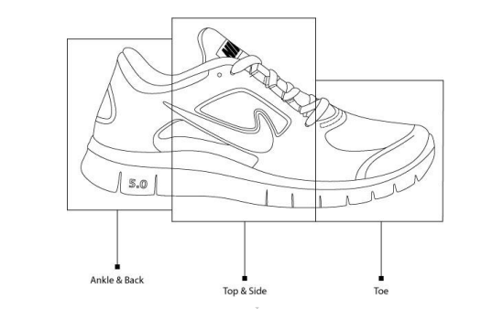

**Figure 1- Regions of Interest for Footwear**

* 1. **Importance of product attributes - intrinsic visual cues**

Previous research of cue utilization theory (Rahman, 2011; Rahman et al., 2009; Szybillo & Jacoby, 1974) indicated that consumers often evaluate clothing quality based on a number of product cues. These product cues can be categorized into intrinsic cues (e.g., fit, color and style) and extrinsic cues (e.g., price, brand name and country of origin). Intrinsic cues refer to those attributes directly attached to the physical product, whereas the extrinsic cues are those intangible attributes indirectly attached to the physical product. Intrinsic cues usually provide higher predictive or diagnostic values than do extrinsic cues (Wall et al., 1991). A study conducted by Li (2011) found that Chinese college students paid more attention to intrinsic cues (style, color and fabric) than to extrinsic cues (brand name, certificate and label information). Although brand name can be used to reduce consumers’ shopping effort, many buyers do not purchase a pair of shoes merely based on the brand without considering the fit and style to satisfy their physical and psychological needs. In a similar vein, Newcomb (2010) also found that intrinsic cues play a more influential role on product evaluation than do extrinsic cues. Due to the relative importance of intrinsic cues, the present study focused primarily on visual aspects of a product (style/design, color and fit/silhouette) because these cues can provide quick and detailed information to the shoppers, in contrast to non-visual cues such as product performance, which require consumption experience (Rahman, 2012). Furthermore, some studies (Schifferstein, 2006; Schifferstein & Cleiren, 2005) confirm that vision is the most important sensory system that consumers use for product identification, recognition, categorization and evaluation. For example, a study (Apeagyei, 2008) conducted in the United Kingdom found that more than 50% of female respondents were capable of evaluating and determining the fit of a garment only based on their visual judgment. For these reasons, in this study a questionnaire survey with cue utilization measuring instrument, and eye-tracking study were employed to investigate the significant of visual attributes of footwear.

* + 1. **Style / design**

‘Style’ can be defined as the combination of design features within a garment (Kunz, 1998), or the garment’s silhouette and structure (Miller et al., 2005). According to a study conducted in the U.S. and Korea (Kawabata & Rabolt, 1999), fit and style/design were ranked as the most important evaluative criteria for clothing purchases. Another study, of Chinese and Korean consumers (Forsythe et al., 1999), also found that design was one of the most significant intrinsic cues for product evaluation. In addition, female teens considered fit and style to be the two most important cues for clothing evaluation in a study by Taylor and Cosenza (2002). Although style/design plays an important role in clothing consumption, consumers may perceive and use this product attribute differently on footwear evaluation. Thus, it is of value to investigate style as part of consumers’ shopping, evaluating and purchasing behaviours in the case of footwear.

* + 1. **Color**

Color information (e.g., hue, light values and bright intensities) can greatly affect consumers’ perceptions, their physiological and emotional reactions, and/or the consumer behavioural intentions of a product (Chu & Rahman, 2012; Valdez & Mehrabian 1994). Color cue is the most visible and appealing element of any consumer product, including footwear (Bevlin, 1997; Rasband, 2001). A qualitative exploratory study of women’s choice of footwear in the United Kingdom (Naidoo et al., 2011) indicated that six out of seven participants cited color as an important factor for footwear selection. Some prior researchers have pointed out that little research has investigated consumers’ shopping motives, selective criteria and (dis)satisfaction with footwear (e.g., Curwen & Park, 2014). Clearly, there is noticeable lack of investigation into the visual cues (style, color and fit) of fashion footwear.

* + 1. **Fit / silhouette**

‘Fit’ can be defined as the way an apparel item conforms to the human body (Workman & Lentz, 2000), or the relationships between an apparel item and body shape (Ashdown & DeLong, 1995). Well-fitted apparel is important to wearers’ physiological comfort, and to their psychological and social well-being (Rahman & Chang, 2018; Smathers & Horridge, 1978-1979). Liechty et al. (2000) suggest that a good fit of clothing can be assessed and determined by three factors: balance, ease of movement, and visual appearance. According to a study conducted in Europe (Outsize, 1998), the most important selection criteria for footwear was fit, followed by quality, and then design. Another study (Piller & Müller, 2004) of selective parameters for customized shoes in four European countries (United Kingdom, Germany, Spain and Italy) found that fit and design were the two most important determinants for both male and female consumers. It is not difficult to understand why fit plays a significant role in footwear evaluation; an ill-fitted shoe may cause or exacerbate foot problems such as discomfort, pain, blistering, bunions, black toes, and deformities.

1. **Report on the Present Investigation**



**A moderator is considered as a staff who can manage orders for the time being. As a future update moderator may give facility to add and manage his own products. Moderators can reduce the work load of admin. Now moderator has all the privilege an admin having except managing other moderators. He can add products and users. He can also check the orders and edit his profile.**

* **Manage Products**
* **Manage Users**
* **Manage Others**

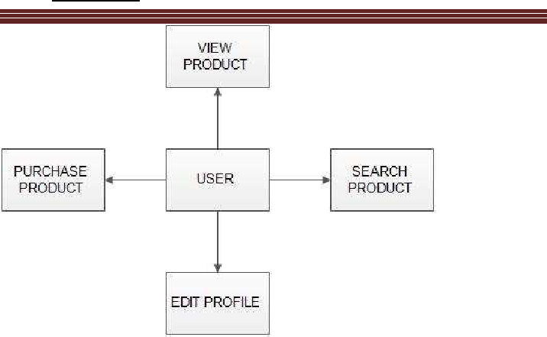**Users:**

* Registration : **A new user will have to register in the system by providing essential details in order to view the products in the system. The admin must accept a new user by unblocking him.**
* Login : **A user must login with his user name and password to the system after registration.**
* View products : **User can view the list of products based on their names after successful login. A detailed description of a particular product with product name,products details, product image, price can be viewed by users.**
* Search product : **Users can search for a particular product in the list by name.**
* Add to cart : **The user can add the desired product into his cart by clicking add to cart option on the product. He can view his cart by clicking on the cart button. All products added by cart can be viewed in the cart. User can remove an item from the cart by clicking remove.**
* Submit cart : **After confirming the items in the cart the user can submit the cart by providing a delivery address .On successful submitting the cart will become empty.**
* Edit profile : **The user can view and edit the profile.**

1. **Outputs Results And Discussions.**

**Figure 2- Home Page**

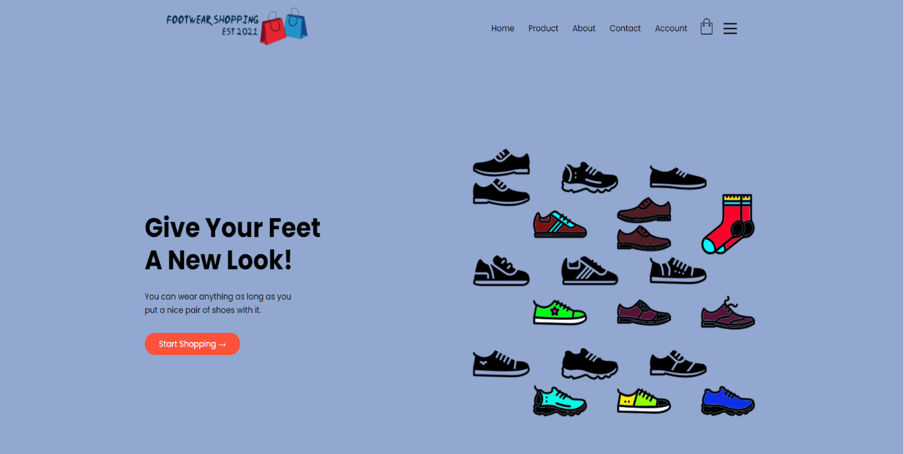**Figure 3- Products Page** 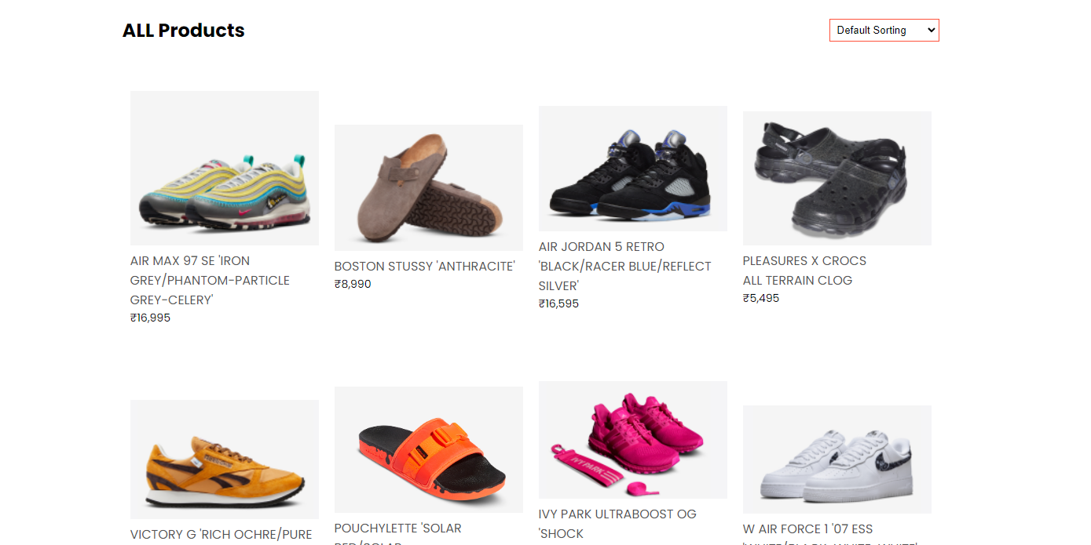

**Figure 4- Cart Page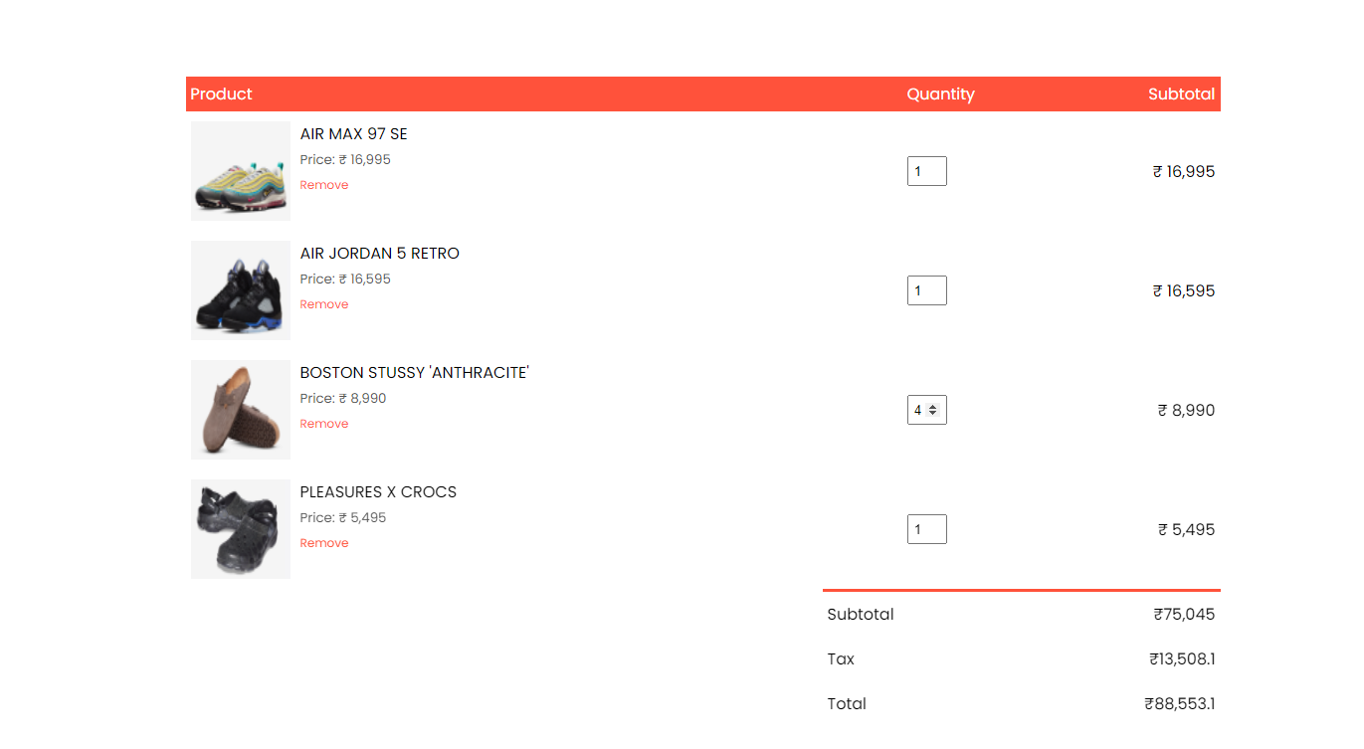Figure 5- Accounts Page**

**Figure 6- Detail Page for Products**

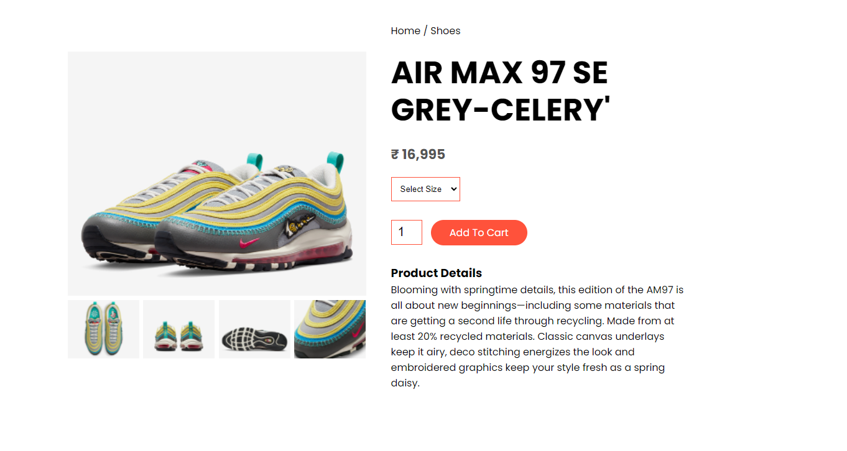**Figure 7- About and Contact Page**

1. **Conclusions**

According to the quantitative and qualitative results of this study, fit and comfort are the two most important factors for footwear evaluation. The study also showed that fit, comfort and style are closely related. These three product cues are often used for footwear evaluation because illfitting shoes may lead to physical pain and discomfort, and inappropriate style may lead to psychological discomfort. Although visual cues such as style, color and fit play a more important role than many other product cues, many consumers are not able to decide on their purchases without touching and trying on the product. Many consumers are not comfortable to purchase footwear online although a few studies reported that consumers are capable and knowledgeable to judge the clothing fit and quality based on its visual representation or physical appearance (Apeagyei, 2008; Rahman, 2012). It could be quite different shopping for a pair of shoes than shopping for clothing. Clearly, consumers do not want to buy any shoes that may lead to physical pain and discomfort, regardless of the attractiveness of the shoes. The reasons why many shoppers have no confidence in judging the fit of shoes online include: (1) the visual representation and text descriptions do not provide enough information about the fit: (2) the sizing systems of footwear are varied across brand names: and (3) some consumers’ feet sizes are beyond the norm (e.g., too small, too wide or too narrow). In order to enhance consumers’ online shopping confidence and experience, footwear retailers should address the aforementioned issuesIn order to provide useful information to online shoppers, fashion retailers should focus on the following areas: understanding shoppers’ navigation styles and patterns, and displaying each visual product alongside reviewers’ comments as well as the availability of shoes sizes.

1. **References**

[1] Internet World Stats (2018). The internet big picture: World Internet users and population stats, Internet World Stats, available at: <http://www.internetworldstats.com/stats.html>

[2]An Empirical Study on Dhaka City, Bangladesh- <https://www.tandfonline.com/doi/full/10.1080/23311975.2018.1514940>

[3] Coughlan, S. (2018). Time spent online ‘overtakes’ TV among youngsters. BBC News, Education & Family, January 26 ,available at <https://www.bbc.com/news/education-35399658>

[4] Rahman, O. & Yu, H. (2018). A study of China and Taiwan. International Journal of Fashion Design, Technology and Education, 11(1), 22-33.

[5] Rahman, O. & Chang, W.-T. (2018). Understanding Taiwanese Female boomers through their perceptions of Clothing and appearance. Fashion Practice: The Journal of Design, Creative Process & the Fashion Industry, 10(1), 53-77.

[6] Rahman, O. & Yu, H. (2018). A study of Canadian Female boomers: Physiological and psychological needs, clothing choice and shopping motives. Journal of Fashion Marketing and Management, 22(4), 509-526.

**Acknowledgements**

We are profoundly grateful to Prof. Reshma Lohar for her expert guidance and continuous encouragement throughout to see that this project rights its target.

We would like to express deepest appreciation towards Dr. Varsha Shah, Principal RCOE, Mumbai and Prof. Shiburaj HOD Computer Department whose invaluable guidance supported me in this project.

At last we must express our sincere heartfelt gratitude to all the staff members of Computer Engineering Department who helped us directly or indirectly during this course of work.

Rohit Nagawelly

Mohammed Jawwad

Shailesh Mishra